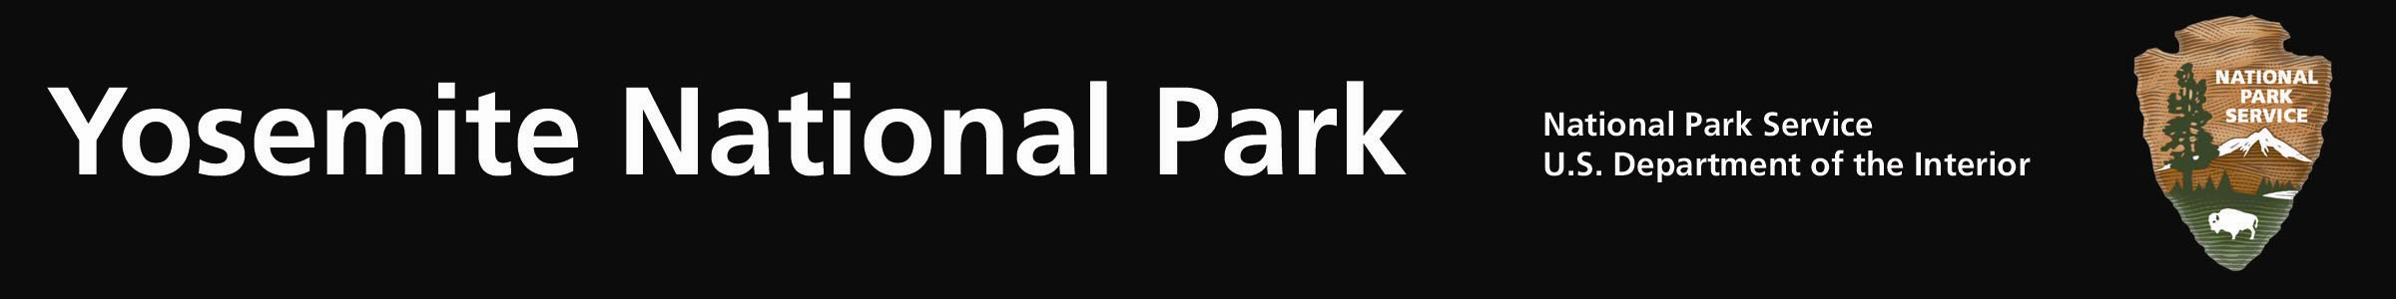
“Motor Fire” – Sierra & Stanislaus National Forests
Fire Update #7 – August 30, 2011
Yosemite National Park is providing this information in cooperation with and support to the South Central Sierra Type II Team and the Sierra and Stanislaus National Forests.
Motor Fire (37.6625 x 119.8714; Sierra National Forest, Mariposa County): The Motor Fire began approximately 12:30 PM, August 25. It was started by a vehicle fire (recreational vehicle) on Hwy 140, along the Merced River and near Cedar Lodge. The fire quickly spread to Sierra and Stanislaus National Forest’s lands.
As of 12:30PM, August 30: This will be the last Motor Fire Update released from Yosemite National Park. The Incident Management Team will continue to provide Motor fire information updates.
Evacuation orders of Rancheria Flat, Incline RD, Cedar Lodge and local campgrounds were lifted at of 9:00pm 8/29/11. Highway 140 was reopened to all traffic at 6:00 am 8/30/11
Although residents are allowed back into their homes, the fire is an active incident. Residents and visitors to the area should remain alert to changing fire conditions.
Highway 140 is open, use caution when travelling in the area due to continuing fire suppression operations and the potential for debris (rocks, logs, etc.) on the roadway.
Fire Status:
- The most active portion of the fire is on the north side of the Merced River in Moss Canyon
- The fire has burned 5,231 acres and is 60% contained
- Approximately 1,200 firefighters are on scene; however resources are being released.
- Air operations may continue to work the fire.
- Steep terrain and hot temperatures continue to make firefighting conditions difficult.
Although the fire is not located in Yosemite National Park, we have been happy to support the fire suppression efforts of the South Central Sierra Interagency IMT, Mariposa County, Sierra and Stanislaus National Forests, and California Highway Patrol. The park is thankful for their work and to the firefighters who continue to make this operation successful.
The fire information call center will shut down at 6:00pm 8/30/11. All further calls concerning the fire should be directed to the Team PIO (951) 225-4516.
More information can be found at: http://inciweb.org/incident/2520/
Turtleback web cam: http://ssgic.cr.usgs.gov/cgi-bin/camHist11.pl?camera=turtleback_2&lastFrame=true
For Air Quality Information: http://www.mariposacounty.org/index.aspx?nid=89

