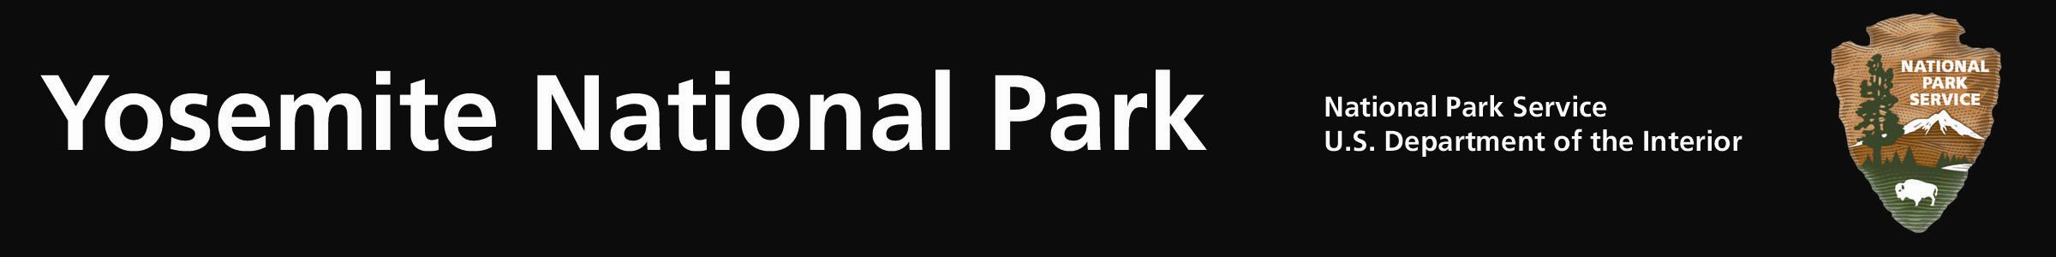
Bishop Creek Prescribed Fire Postponed Indefinitely

Yosemite National Park fire managers have postponed indefinitely, the 5,224 acre Bishop Creek Prescribed fire which was scheduled to begin Friday, September 30, 2011. The primary reasons for the delay are current and predicted environmental conditions including strong gusty winds. Eye level winds yesterday were consistently out of prescription and ridge top winds at the test burn site were gusting to 35 mph. These winds also caused the Tamarack wildfire, along the Tioga Road and managed for multiple objectives, to have three consecutive days of significant growth.

The primary objective of the Bishop Creek prescribed fire is Wildland Urban Interface Protection. The project will buffer the communities of Yosemite West, Wawona and El Portal, and the Glacier Point Historical District from unwanted wildfire by reducing an over accumulation of fuels. The preparation and planning work for this prescribed fire will continue as conditions allow for the project to be completed in the future.

Additional Information:
- Fire Information and Education: Gary_Wuchner@nps.gov; (209) 375-9574 or (209) 372-0480.
- Yosemite Fire Management Website: http://www.nps.gov/yose/parkmgmt/current_fire.htm
- Twitter: http://twitter.com/YosemiteFire
- Facebook: http://www.facebook.com/pages/Yosemite-Wildland-Fire/124632964255395

