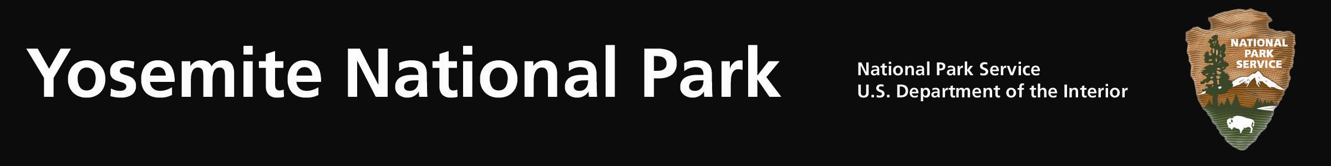
Bishop Creek Prescribed Fire – To Begin October 24, 2011

The Rail Creek, Segment A, of the 5,224 acre Bishop Creek prescribed fire unit, is scheduled to begin Monday, October 24, 2011, dependent upon favorable weather and air quality. Segment A is 1,400 acres and one of five segments within the unit. It is estimated to take firefighters four to five days to complete this project.

The primary objective is Wildland Urban Interface Protection. The project will buffer the communities of Yosemite West, Wawona and El Portal, and the Glacier Point Historical District from unwanted wildfire by reducing an over accumulation of fuels. The start of the project will begin with a blackline firing operation at the top of the unit.

It will build off the recent 1,068 acre Avalanche Fire, other prescribed fires and mechanical thinning treatments in Yosemite’s suppression and wilderness fire management units. The Bishop Creek project is directly adjacent and east of the Wawona Road, and the Avalanche fire to the north. The unit is bisected by the east/west oriented Rail, Strawberry and Bishop Creek drainages with a primarily west facing aspect.

The vegetation consists of long needle ponderosa pine/mixed conifer on the lower slopes, and short needle white and red fir mixed conifer further upslope. Pockets of chinquapin, whitethorn, and manzanita and bear clover exist. There is an accumulation of other dead and down vegetation, including logs, limbs and other surface fuels.

Since 1930, there have been over 50 suppressed lightning ignitions in the footprint of the Bishop Creek Project. In 1981, there was a 2,100 acre prescribed fire. In 1997 a 100’ to 200’ wide mechanical thinning project have occurred along the Wawona Road (Hwy 41). There have been multiple prescribed fuel treatments near the community of Yosemite West (2005 and 2007). Between 1910 and 1926, the area was logged for prized Sugar Pine trees.

Most of the proposed project is within designated wilderness. In accordance with the wilderness Act of 1964, Minimum Impact Management Techniques will be employed to preserve the wilderness integrity. A resource advisor will be assigned to the project to advise on cultural and natural resources. The fall season is the preferred implementation period for this project. Fall benefits include fewer impacts to all wildlife, and more complete ground and surface fuel consumption and less resource damage due to post fire mop-up efforts. In all cases, mitigations will be taken to protect sensitive natural and cultural resources.

Smoke, which can affect health, is always a factor in the decision making process to conduct this and other prescribed fire projects. A smoke management plan has been submitted to the Mariposa County Air Pollution Control District (APCD), and a burn plan has been issued. The Tuolumne County, the San Joaquin and Great Basin APCDs have been advised of this project. Smoke monitors have been deployed in smoke sensitive areas.

Additional Information:
- Fire Information and Education: Gary_Wuchner@nps.gov; (209) 375-9574 or (209) 372-0480.
- Yosemite Fire Management Website: http://www.nps.gov/yose/parkmgmt/current_fire.htm
- Air Quality: http://www.nps.gov/yose/naturescience/aqmonitoring.htm
- Yosemite NP WEBCAMS: http://www.nps.gov/yose/photosmultimedia/webcams.htm
- Twitter: http://twitter.com/YosemiteFire
- Facebook: http://www.facebook.com/pages/Yosemite-Wildland-Fire/124632964255395

