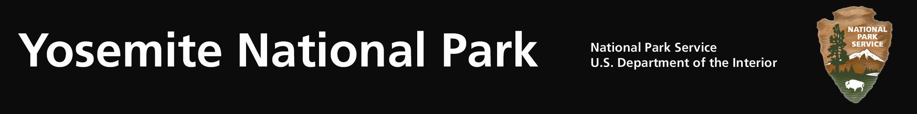
Yosemite Fires - Update #15 – August 22, 2011

Avalanche Fire: (N37 39.794 x W119 42.238; 6,400’el. Mariposa Co.) The Avalanche fire is a lightning caused fire in congressionally designated Wilderness near the vicinity of Chinquapin. The fire has been burning since it was discovered on the afternoon of July 31, 2011 during a reconnaissance flight near Avalanche Creek and Glacier Point Road.

The 1068 acre fire is contained within the confines of Glacier Point, Wawona, and Old Glacier Point Roads. A more concise mapping was conducted reflecting the reduced acreage. The decision to contain the fire was made for several reasons including:
- Weather forecasts for the next several days indicate poor smoke dispersal; containing the fire will lessen potential negative smoke impacts to adjacent communities
- Public and firefighter safety along Glacier Point Road and Wawona Road with anticipated increased traffic during the upcoming Labor Day Holiday
- Monetary costs associated with retaining firefighting resources and logistical support during periods of less than ideal smoke dispersal conditions.

Park fire managers and firefighters are sensitive to smoke, visitation, and human health concerns. The park is collaborating with the Mariposa County Air Pollution Control District (MCAPCD) by communicating daily concerning potential air quality impacts, mitigations, and to support each agency’s responsibility to public health. Air monitoring equipment is installed within Yosemite West, El Portal and Yosemite Valley to obtain daily air quality levels. Landscape features have been identified as management action points within the fire perimeter to limit the fire’s spread. The fire line is along roads, trails, and previous fire footprints.

Light smoke continues to be present along the roadways as the fire continues to smolder within the fire perimeter. As firefighters and fire equipment work along the roads, drivers are urged to adhere to posted 25mph speed limits, possible single lane closures and traffic officer instructions.

Yosemite Crew 7, 10 firefighters, continue to secure the perimeter by “mopping up” or extinguishing logs, stumps, etc. that are burning along the fire’s edge.

The Avalanche fire, combined with previous fires, roadside mechanical thinning, vegetation debris pile burning, and prescribed fires, provides defensible space to the communities of Yosemite West, Badger Pass Ski Resort, Glacier Point and other park infrastructure by reducing litter, duff, and downed woody debris. This fire now adds over 1000 additional defensible fire buffer acres to these communities. Managing naturally occurring lightning fires is consistent with the current Yosemite Fire management Plan and Environmental Impact Statement.

For additional Information:
- Fire Information and Education: Gary_Wuchner@nps.gov; (209) 375-9574 or (209) 372-0480.
- Yosemite Fire Management Website: http://www.nps.gov/yose/parkmgmt/current_fire.htm.
- For air quality information: http://www.nps.gov/yose/naturescience/aqmonitoring.htm

