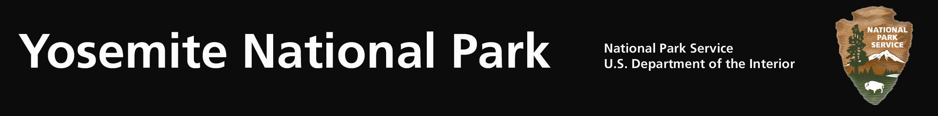
Yosemite Fires - Update #13 – August 17, 2011

Avalanche Fire: (37 39.794 x 119 42.238; 6,400’el. Mariposa Co.) This lightning caused fire has been burning in Yosemite National Park since it was discovered on the afternoon of July 31, 2011. The fire was observed during a reconnaissance flight near Avalanche Creek and Glacier Point Road within Yosemite’s congressionally designated wilderness area. Due to a strong high pressure weather system, poor smoke air dispersion and potential negative smoke impacts the fire is being held at 1,045 acres.

Smoke is visible from the Valley, Glacier Point Road and in the direction of transport winds. Park fire managers and firefighters are sensitive to smoke, visitation, and human health concerns and therefore diligently timed burning operations to coincide with optimal smoke dispersion. The park is collaborating with the Mariposa County Air Pollution Control District (MCAPCD) by communicating daily concerning potential air quality impacts, mitigations, and to support each agency’s responsibility to public health.

Air monitoring equipment is installed within Yosemite West, El Portal and Yosemite Valley to obtain daily air quality levels. Landscape features have been identified as management action points within the fire perimeter to limit the fire’s spread. The fire line is along roads, trails, and previous fire footprints. Actions may be used by firefighters to minimize and reduce smoke impacts, such as helicopter water drops to cool portions of the fire.

Smoke continues to be present along the roadways. As firefighters and fire equipment work along the roads, drivers are urged to adhere to posted 25mph speed limits, possible single lane closures and traffic officer instructions.

The fire has backed down to the Chinquapin facility and along the Glacier Point Road portion of the fire perimeter. The fire is being held along the historic Old Glacier Point Road to the south. Eighty-five firefighters and managers are committed to the fire, including units from the USFS and BLM. Fire resources are also being released from the fire.

Combined with previous fires, roadside mechanical thinning, vegetation debris pile burning, and prescribed fires, this fire is providing a defensible fire buffer to the communities of Yosemite West, Badger Pass Ski Resort, Glacier Point and other park infrastructures. Although numerous fires have occurred adjacent, the most recent being the 2009, 3,500 ac. Grouse Fire, this area has no recorded fire history. Extensive logging did occur in the early 1900’s.

Managing naturally occurring lightning fires is consistent with the current Yosemite Fire management Plan and Environmental Impact Statement.

For additional Information:
- Fire Information and Education: Gary_Wuchner@nps.gov; (209) 375-9574 or (209) 372-0480.
- Yosemite Fire Management Website: http://www.nps.gov/yose/parkmgmt/current_fire.htm.
- For air quality information: http://www.nps.gov/yose/naturescience/aqmonitoring.htm

