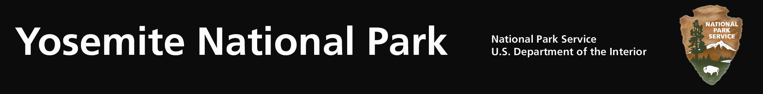
Yosemite Fires - Update #12 – August 15, 2011

Avalanche Fire: (37 39.794 x 119 42.238; 6,400’el. Mariposa Co.) This lightning caused fire has been burning in Yosemite National Park since it was discovered on the afternoon of July 31, 2011. The fire was observed during a reconnaissance flight near Avalanche Creek and Glacier Point Road within Yosemite’s congressionally designated wilderness area. The fire is at 940 acres. At present the fire continues to be managed for multiple objectives including resource values, community protection and firefighter safety.

Smoke is visible from the Valley, Glacier Point Road and in the direction of transport winds. Park fire managers and firefighters are sensitive to smoke, visitation, and human health concerns and are therefore diligently timing burning operations to coincide with optimal smoke dispersion. The park is collaborating with the Mariposa County Air Pollution Control District (MCAPCD) by communicating daily concerning potential air quality impacts, mitigations, and to support each agency’s responsibility to public health.

Air monitoring equipment is installed within Yosemite West, El Portal and Yosemite Valley to obtain daily air quality levels. As the fire continues to grow, landscape features have been identified as management action points within the planned perimeter. Much of the proposed fire line is along roads, trails, and previous fire footprints. These geographic points could limit fire spread when air dispersion is poor, and then can be accelerated when the atmospheric conditions improve. Actions may be used by firefighters to minimize and reduce smoke impacts, such as helicopter water drops to cool portions of the fire.

Firefighters remain on scene through nighttime hours to insure holding the fire to the east of Glacier Point Road. As the fire moves closer to the roadways, the presence of firefighters, fire equipment and smoke will increase. Drivers are urged to adhere to posted 25mph speed limits, possible single lane closures and traffic officer instructions.

Firefighters have begun to back the fire down to the Chinquapin facility and complete the Glacier Point Road portion of the fire perimeter. One hundred and six firefighters are committed to the fire, including units from the USFS and BLM.

Combined with previous fires, roadside mechanical thinning, vegetation debris pile burning, and prescribed fires, this fire will provide a defensible fire buffer to the communities of Yosemite West, Badger Pass Ski Resort, Glacier Point and other park infrastructures. Although numerous fires have occurred adjacent, the most recent being the 2009, 3,500 ac. Grouse Fire, this area has no recorded fire history. Extensive logging did occur in the early 1900’s. Given the time of the year and seasonal severity below normal for time of year, this fire will meet the objectives with minimal risk to other values, including firefighter and public safety, federal and public property, air quality, and wilderness values and character.

Managing naturally occurring lightning fires is consistent with the current Yosemite Fire management Plan and Environmental Impact Statement.

For additional Information:
- Fire Information and Education: Gary_Wuchner@nps.gov; (209) 375-9574 or (209) 372-0480.
- Yosemite Fire Management Website: http://www.nps.gov/yose/parkmgmt/current_fire.htm.
- For air quality information: http://www.nps.gov/yose/naturescience/aqmonitoring.htm

