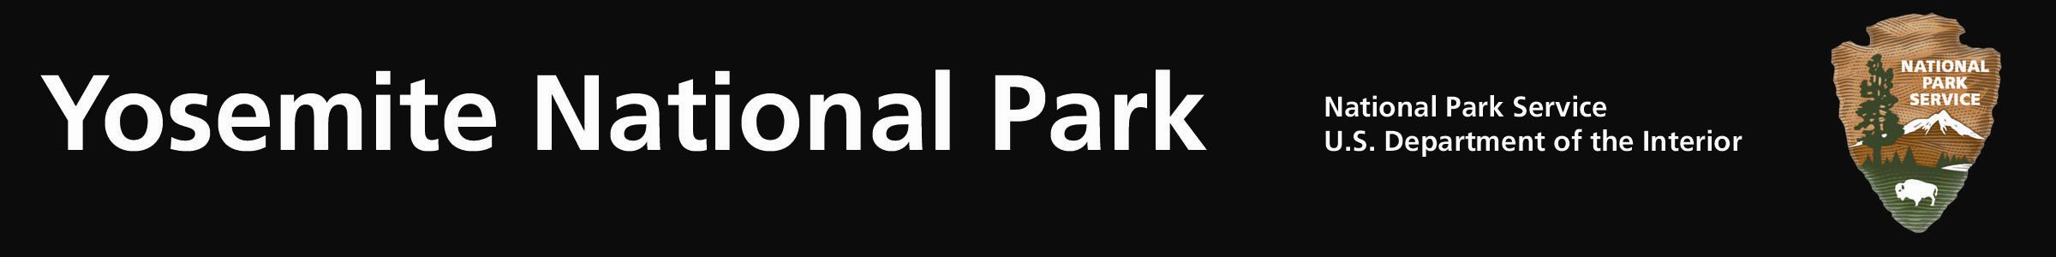
Yosemite Fires - Update #10 – August 10, 2011

Avalanche Fire: (37 39.794 x 119 42.238; 6,400’el. Mariposa Co.) This lightning caused fire was found on the afternoon of July 31, 2011. The fire is at 404 acres. The fire could potentially grow to 5,800 acres.

Firefighters are igniting fuels (firing) along spur ridges to bring a backing fire towards Glacier Point Road. The operation will increase the acres and amount of visible smoke. Firefighters remain on scene through nighttime hours to insure holding the fire to the east of Glacier Point Road. As the fire moves closer to the roadways, the presence of firefighters, fire equipment and smoke will increase. Drivers are urged to adhere to posted 25mph speed limits, possible single lane closures and traffic officer instructions.

Combined with previous fires, roadside mechanical thinning, vegetation debris pile burning, and prescribed fires, this fire will provide a defensible fire buffer to the community of Yosemite West, Badger Pass Ski Resort, Glacier Point and other park infrastructures. Although numerous fires have occurred in the area, the most recent being the 2009, 3,500 ac. Grouse Fire, this area has no recorded fire history. Extensive logging did occur in the early 1900’s. Given the time of the year, seasonal severity, fuels, weather and topography, this fire will meet the objectives with minimal risk to other values, including firefighter and public safety, federal and public property, air quality, and Wilderness values and character.

The fire is within the park’s Wilderness boundary and will be managed for multiple objectives. The fire is creeping and smoldering through duff and other surface fuels. Another rational for this fire is to restore landscape resiliency in a portion of the park that has not burned in recent history. Lightning fires have shaped the forest landscape for thousands of years. The fire will rid the forest of an overabundance of dead and down surface fuels and smaller diameter shade tolerant trees. Wildland fires create open spaces (mosaics) within dense forest, allowing sunlight to penetrate the forest floor. The fire will enhance wildlife habitat and the ability of animals to move through the forest.

Smoke is visible from many locations along the Wawona and Big Oak Flat Roads, from the community of El Portal, and locations outside of the park. Fire managers are working closely with the Mariposa County Air Pollution Control District concerning potential air quality impacts. Yosemite’s Division of Resources and Sciences crews have installed air quality monitoring equipment within the communities of Yosemite West, El Portal and Yosemite Valley. Several fire management action points have been identified where the fire could be held when air dispersion is poor, and then can be accelerated when the atmosphere has more capacity. Actions may be used by firefighters to minimize and reduce smoke impacts, such as helicopter water drops to cool portions of the fire.

For additional Information:
- Fire Information and Education: Gary_Wuchner@nps.gov; (209) 375-9574 or (209) 372-0480.
- Yosemite Fire Management Website: http://www.nps.gov/yose/parkmgmt/current_fire.htm.

